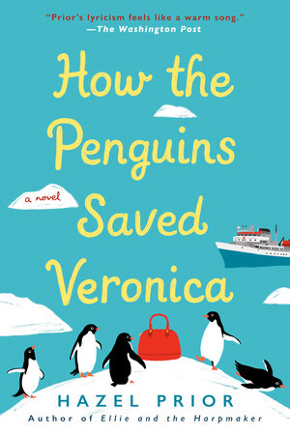

How the Penguins Saved Veronica

Reader’s Guide

BY HAZEL PRIOR

Questions for Discussion
1. The story is told from the viewpoint of an old lady and a young man. What issues does Veronica have with Patrick when she first meets him? What issues does Patrick have with Veronica? Are they right in their assumptions? Do you think their judgments are typical of the way the older and younger generations view each other?
2. There are many types of caring in the story. What are they, and which do you think is most important?
3. Veronica McCreedy does not cry. How has this suppression of feelings affected Veronica’s life? Is it ever good to hide how you feel?
4. The diary sections set in wartime Britain highlight a different lifestyle and values from those we have in the twenty-first century. Which aspects are better and which are worse now?
5. In what ways is Veronica manipulative? In what ways does she also expect others to be manipulative? Is this a forgivable trait?
6. You learn more about the characters’ backgrounds as you read further into the novel. Did your opinion of any of them change? If so, how?
7. Have you ever found it easier to talk to an animal/bird than to a human? What is the role of Pip the Penguin in the novel?
8. Which character do you most admire, and why?
9. Terry says: “Human intervention has harmed wildlife beyond belief.” Is she right? What can we do to remedy the situation?
10. What do you think Veronica learned from the penguins?

