How to Use TinkerCad: Halloween Pumpkin Edition

We will learn how to use 3D modeling software to create .STL files. Specifically, we will be using TinkerCad to create a Halloween pumpkin, and learn how to get the file ready for 3D printing.
Step 1: Create a New Design and Name It Properly.
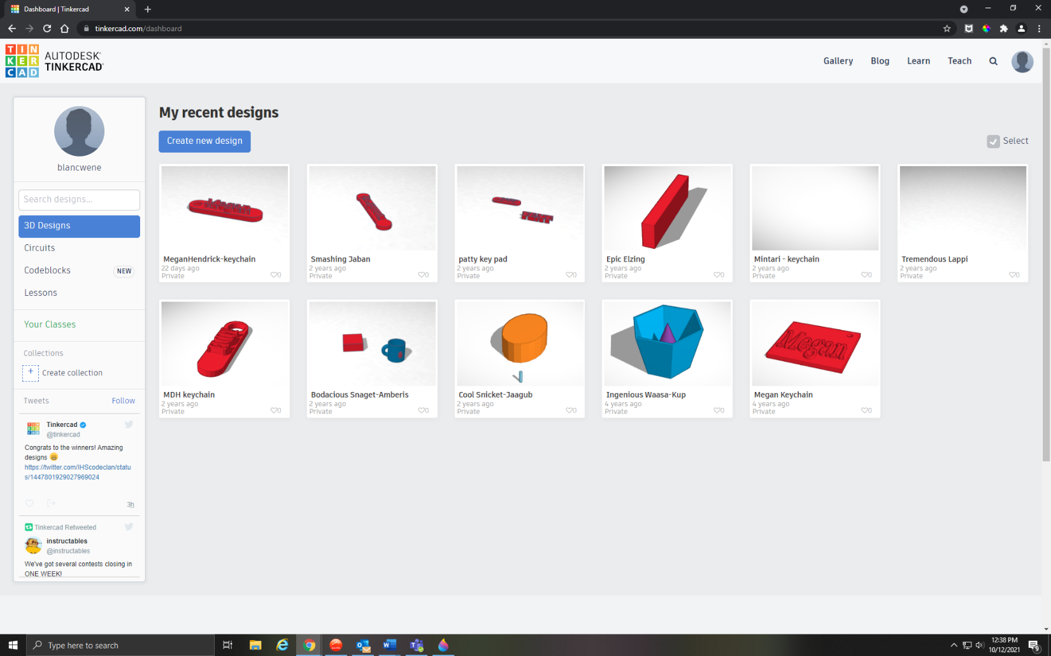
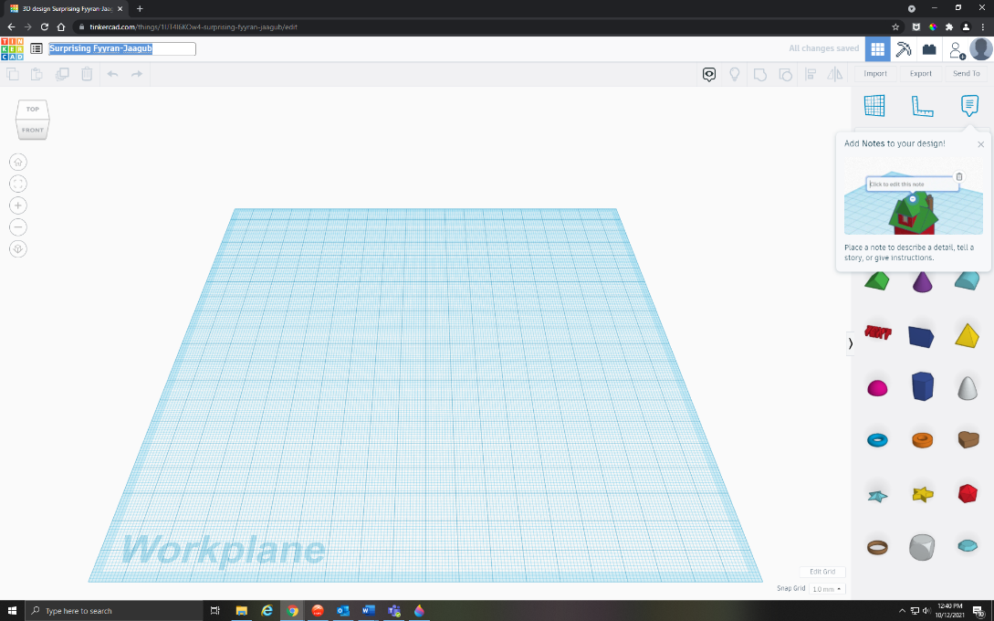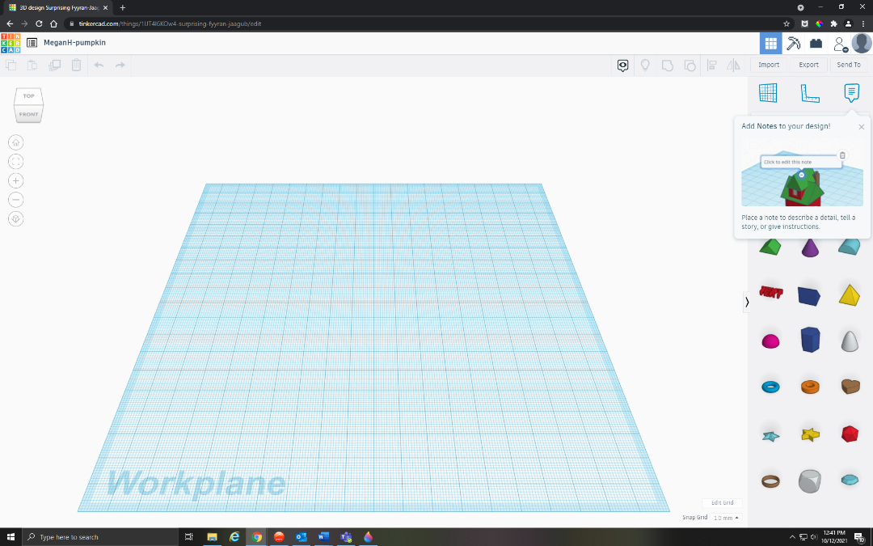
Click on Create new design and once in the working space to rename the file.

You should rename the file FirstnameLastName-Pumpkin.

Drag a Ruler onto your Workplane from the toolbar on the right.
Step 2: Start with a Sphere.
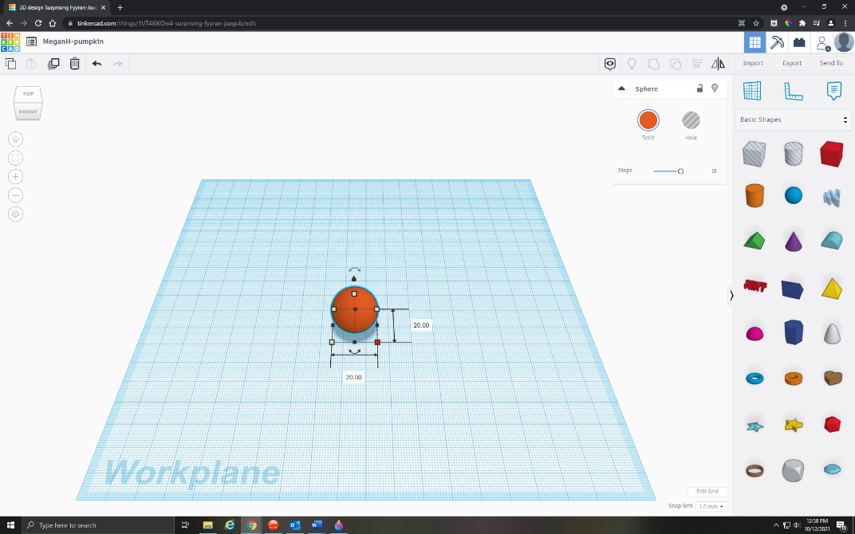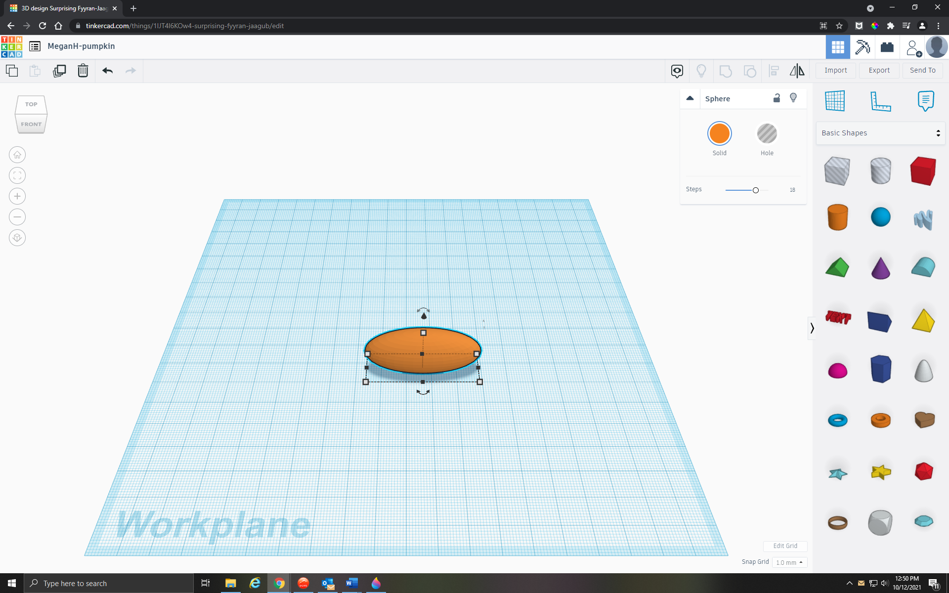
On the right side of the screen, click on the shape that says Sphere.

Drag the Sphere onto the Workplane.

Adjust the dimensions of the sphere by clicking on the numbers next to the separate dimensions.

Change the Width to 15 and the length to 45. We’re going to leave the height alone for now.
Step 3: Create the Pumpkin Shape.

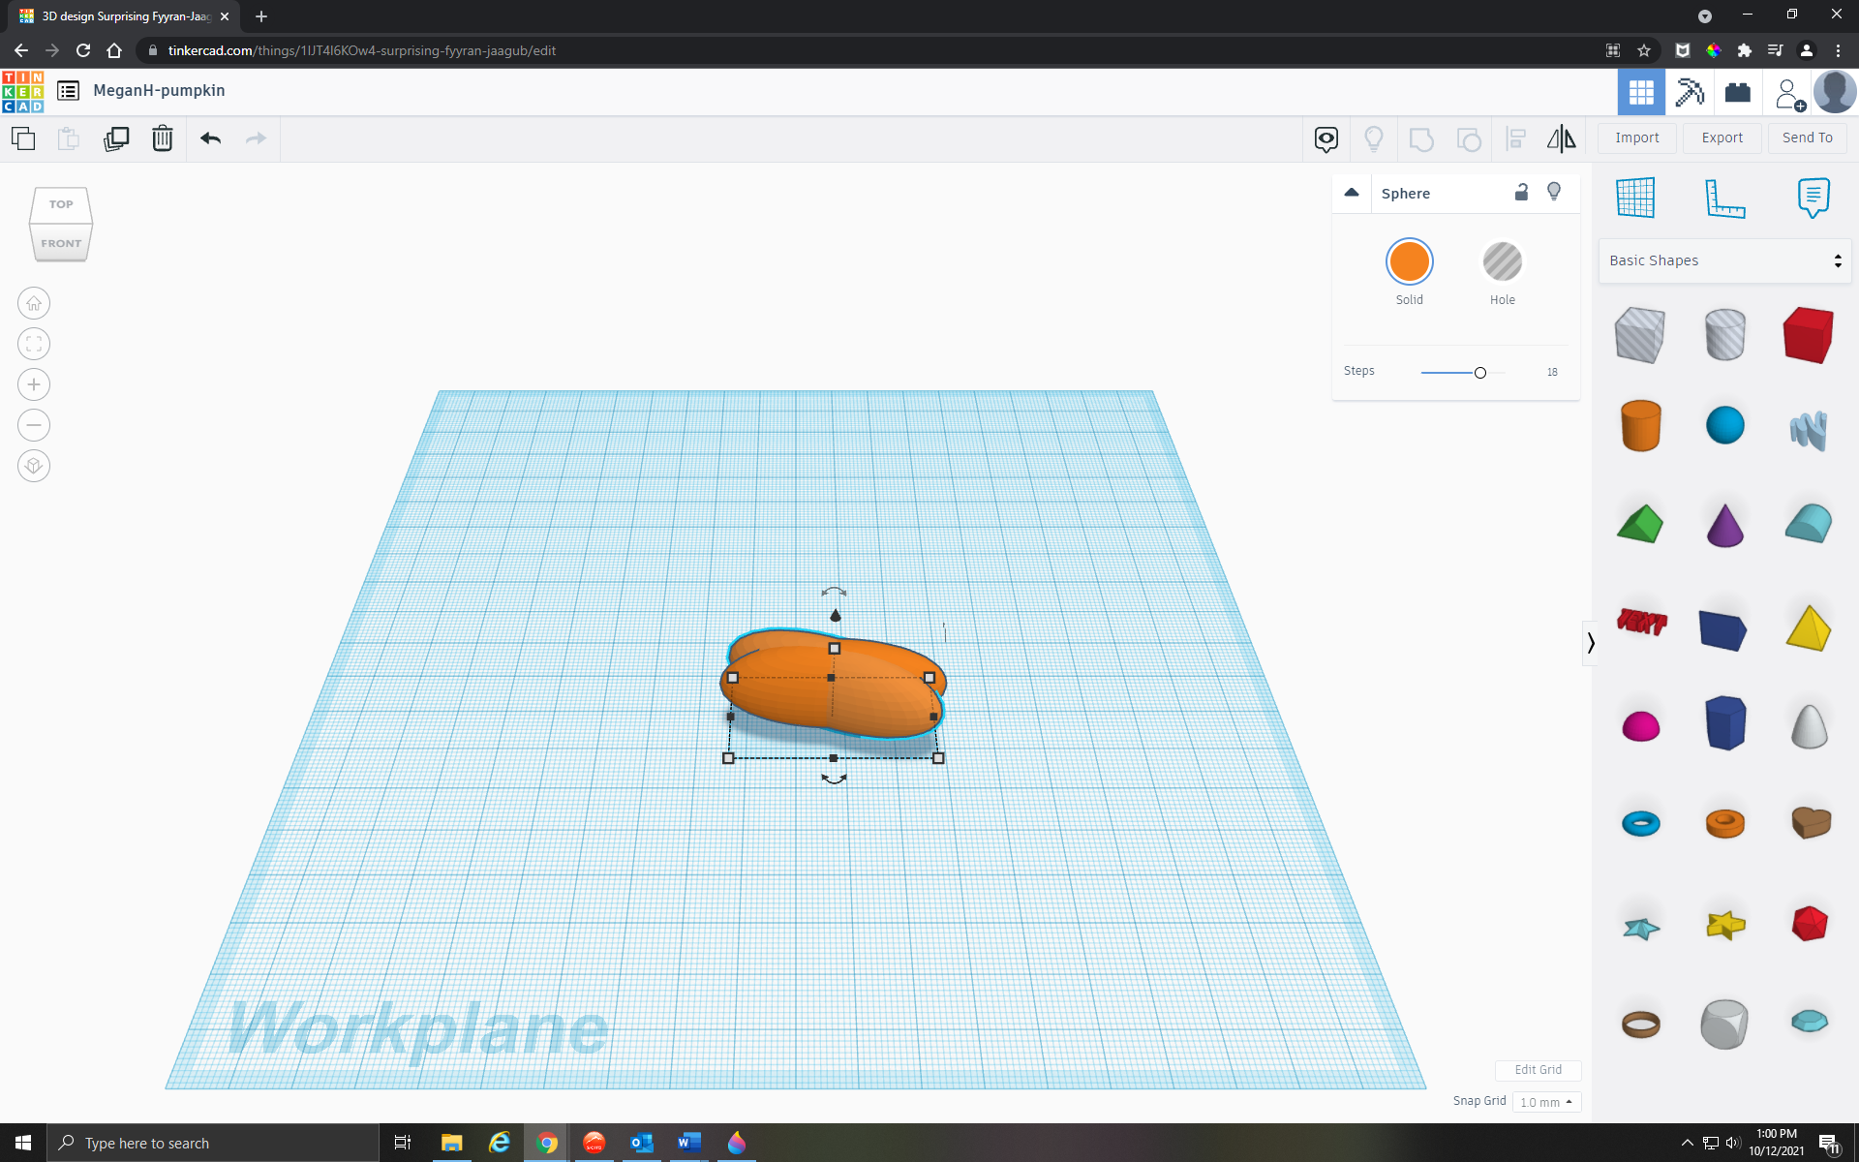

Click CTRL + D to duplicate your sphere (you can also use the duplicate button on the copy/paste menu, third from the left).

Clicking on the rotate icon on your sphere, rotate your duplicated sphere 22.5 degrees. Then without touching anything else, click CTRL + D again and again (six times!) until you have your pumpkin shape.
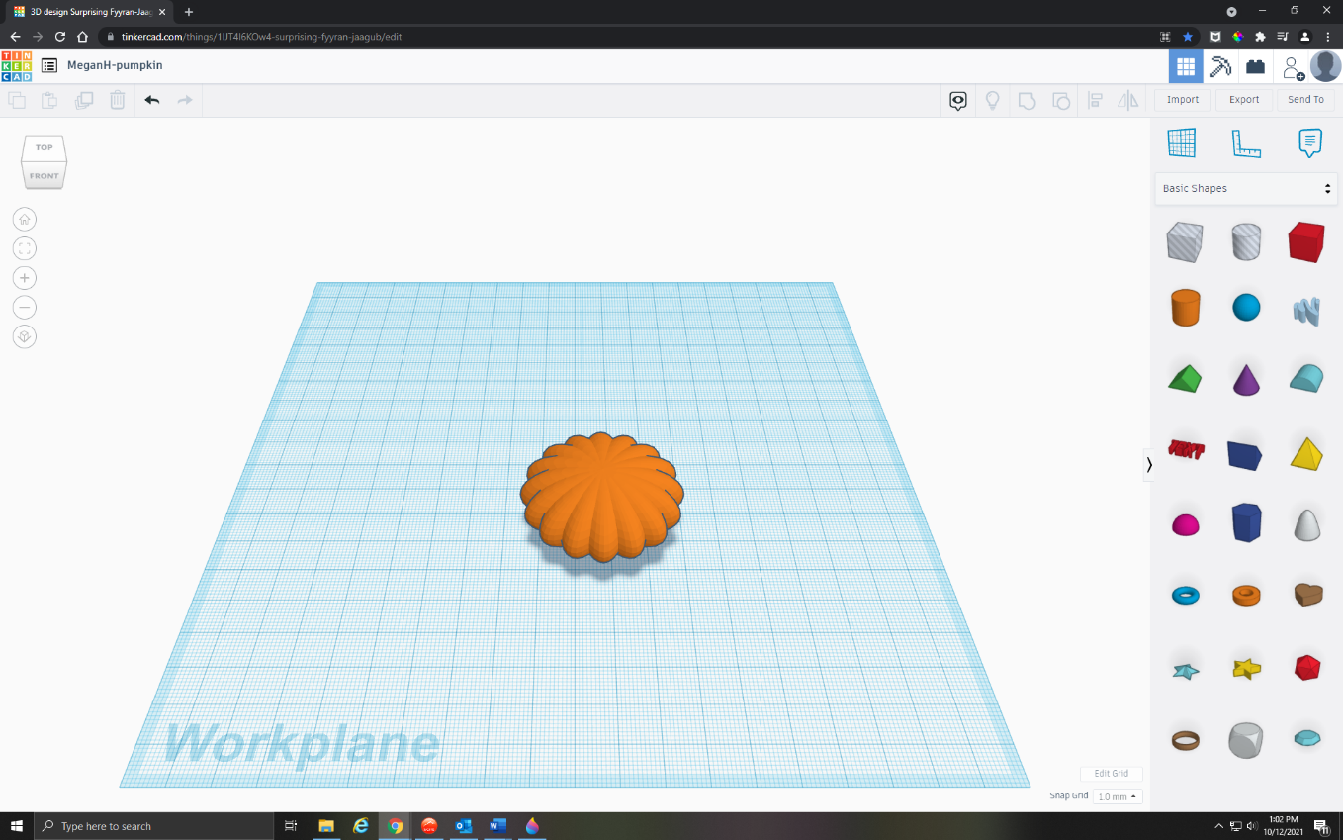

Select your entire pumpkin, then on your keyboard hit CTRL + G to group everything together.

Your pumpkin should now be one piece if you try to move it around.

Now adjust the height of your pumpkin to 40 so that it’s nice and tall.

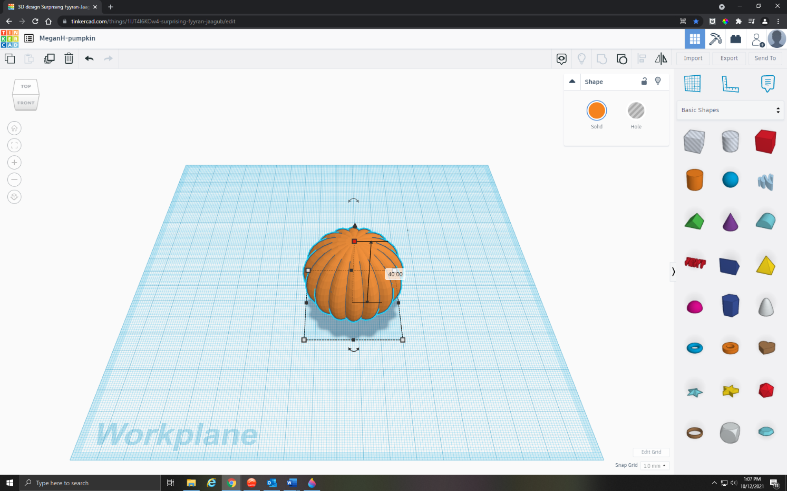

Step 4: Hollow Out Your Pumpkin

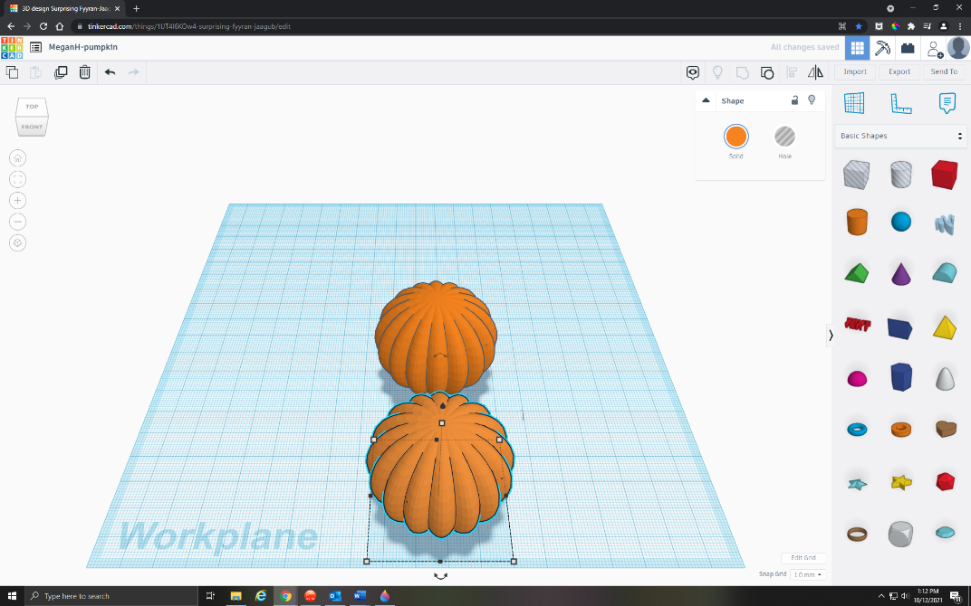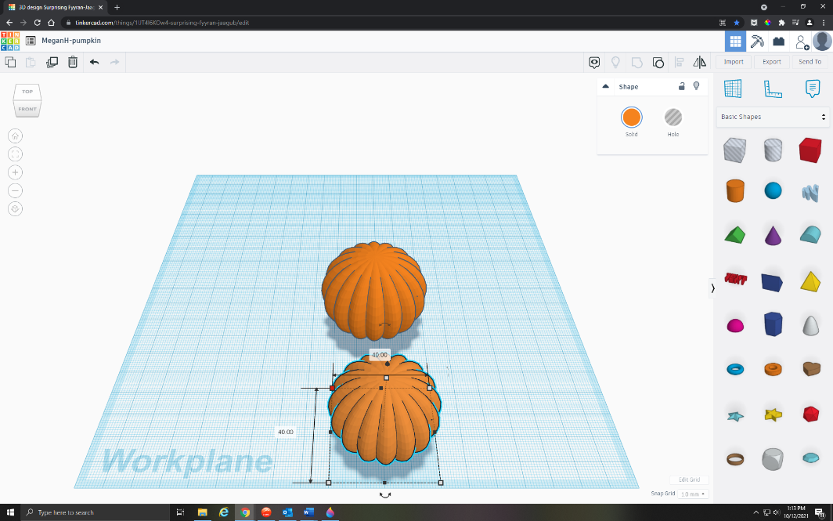
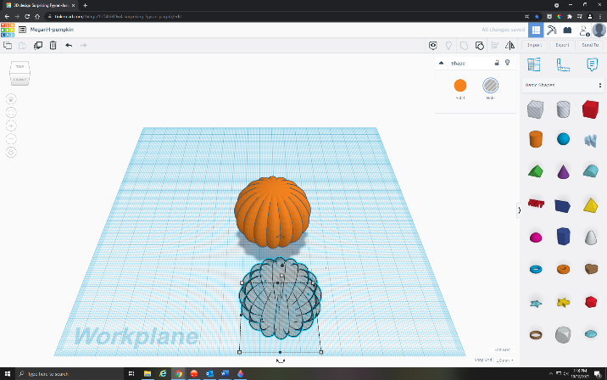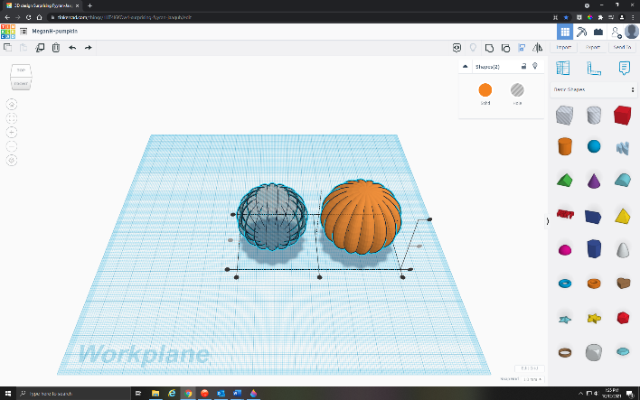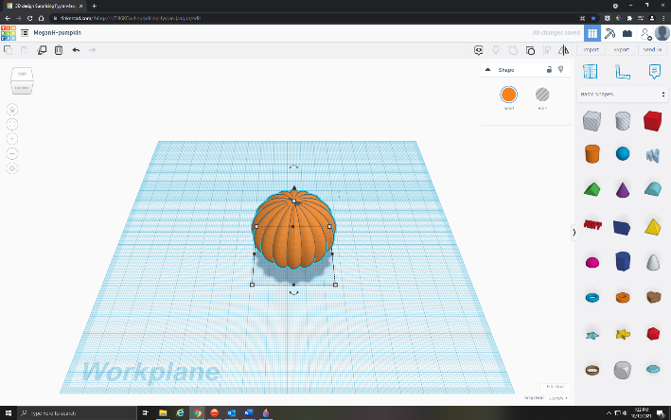

To cut out the interior of your pumpkin, hit CTRL + D to duplicate your pumpkin, and move the second pumpkin over a little bit.

Click the boxes to display the length and width, then hold down SHIFT while dragging to evenly scale your second pumpkin.

Change the length and the width to 40 (so that when you place it inside the first pumpkin, your finished pumpkin will be 5 millimeters thick all the way around and the rest will be empty space).

Switch your second pumpkin from Solid to a Hole.

Drag your mouse to select both pumpkins, then click L or Align. You want to line up the centers height-wise and width-wise. Then using the Arrow Keys, slowly move your second hole pumpkin until it’s surrounded by the bigger solid pumpkin (you want the centers to line up).

Drag to select the pumpkins, then click CTRL + G to group them together.

Your pumpkin is now hollow!

Step 5: Add Eyes to Your Pumpkin.

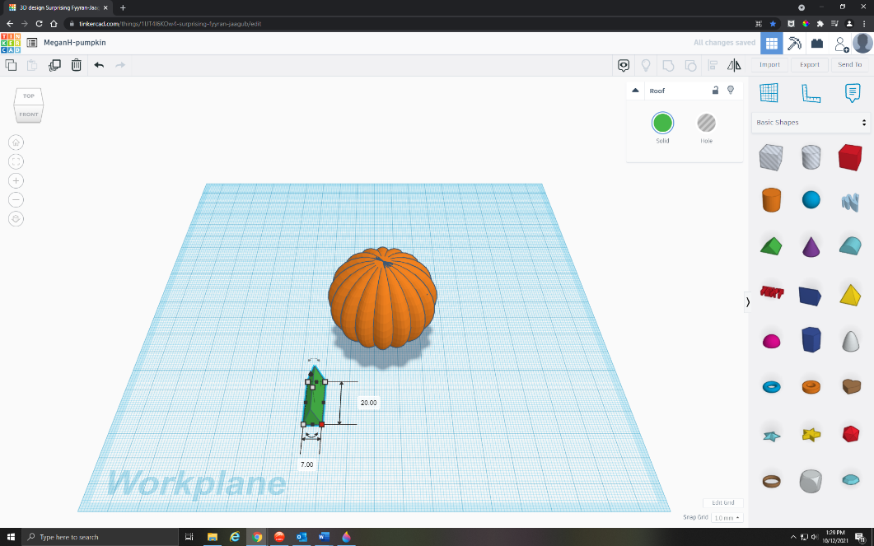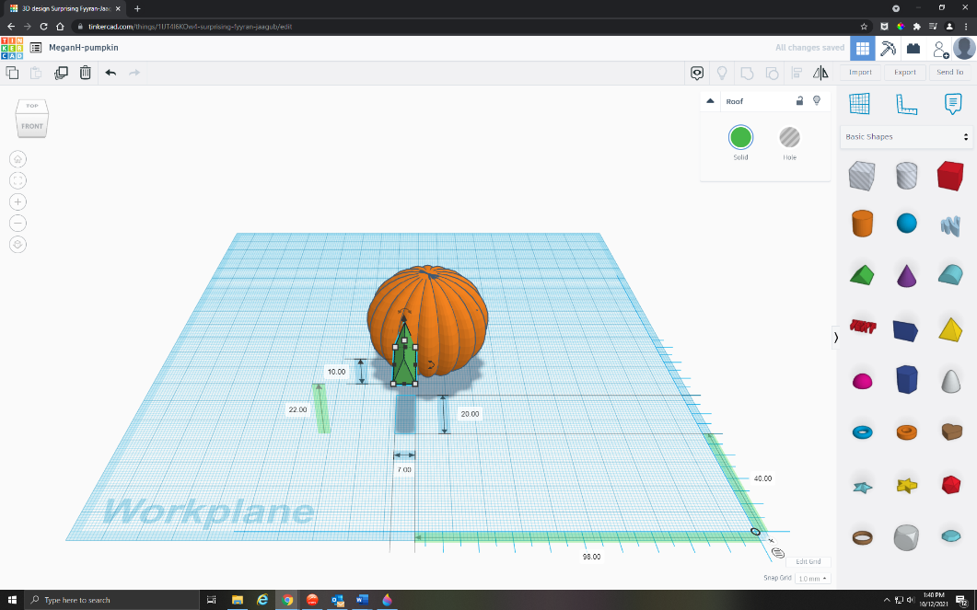
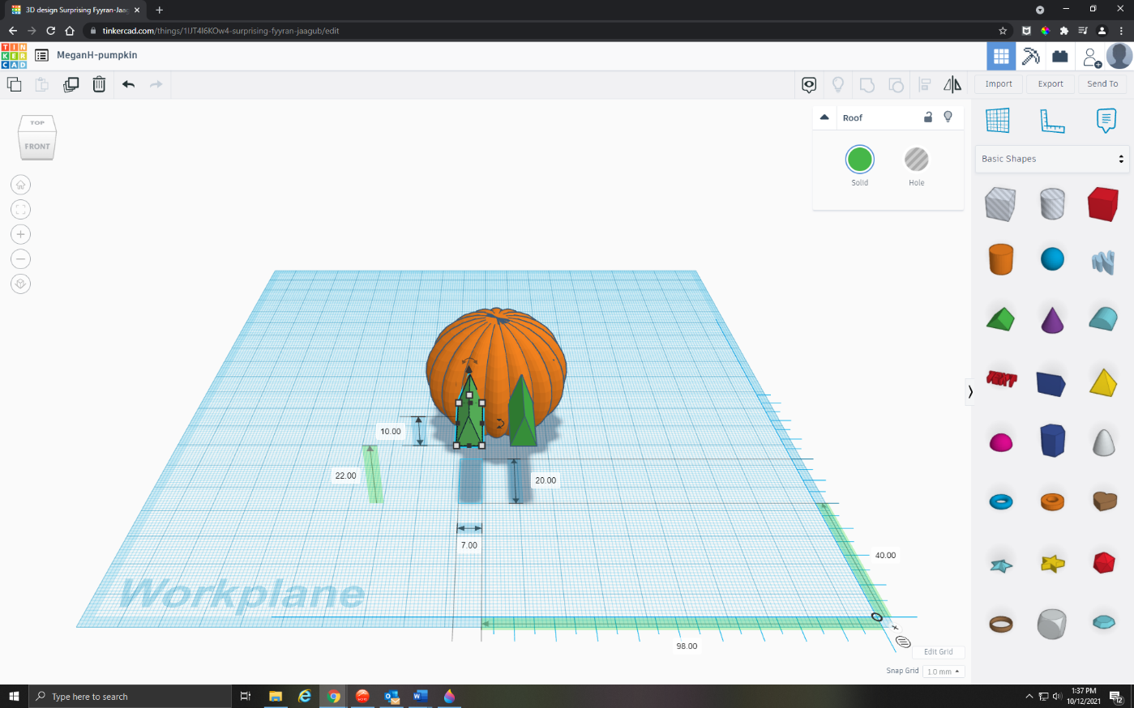
2 More Images

On the right side of the screen, click on the shape that says Roof.

Drag the shape onto the Workplane, and change the height to 7. (The other dimensions can stay the same.)

IMPORTANT: Make sure that you have dragged a Ruler onto the Workplane, or the next step won’t work!

On the Z Axis, you should see a dimension for height above the Workplane—right now, this is 0.00, and it’s indicated by an upward pointing arrow.

Adjust that dimension to the height you like—I chose 22.

Once you have the height you like, click CTRL + D to duplicate your shape.

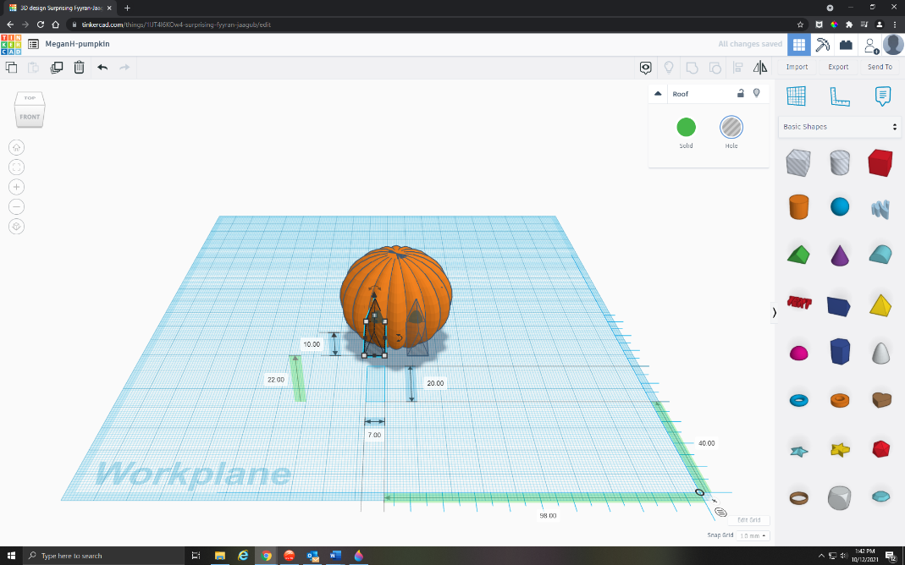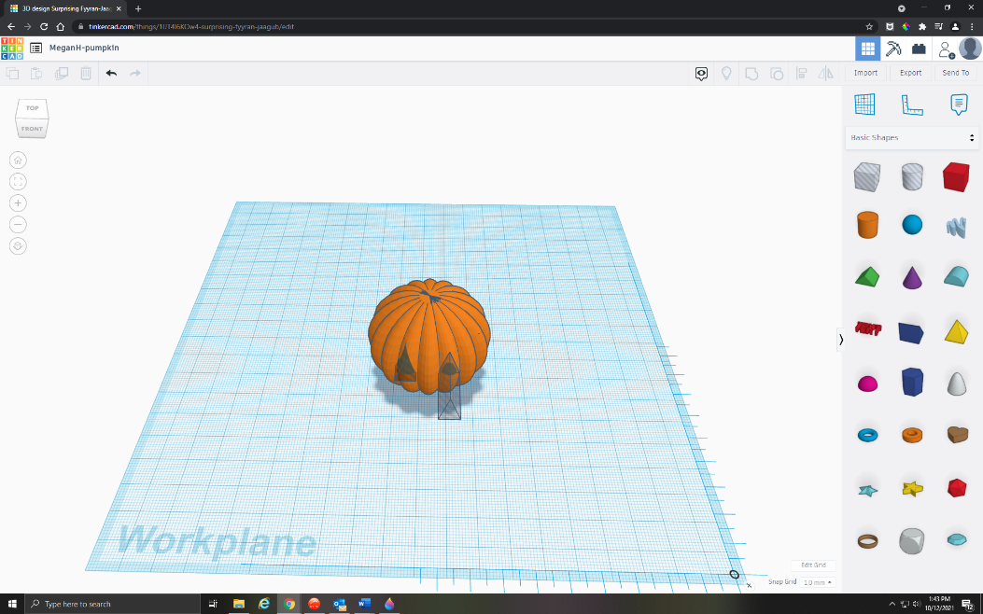
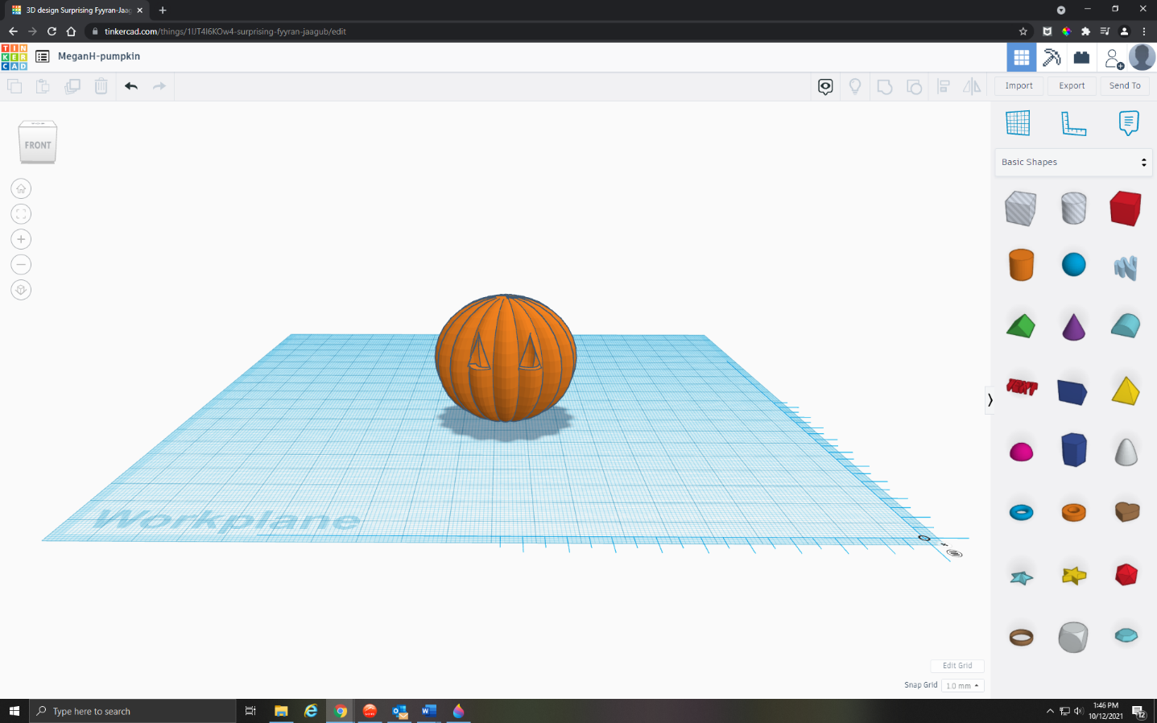

Change both your eye shapes from Solid to Hole.

Move the first eye slowly into your pumpkin, using the Top Arrow Key. Don’t push it entirely inside, because we want to leave some sticking out so that it completely forms the eye hole. Repeat with the second eye.

Select your entire pumpkin, then click CTRL + G to group everything together again.

You should now have a pumpkin with two eye holes!

Step 6: Give Your Pumpkin a Mouth – Smiley Face Version.

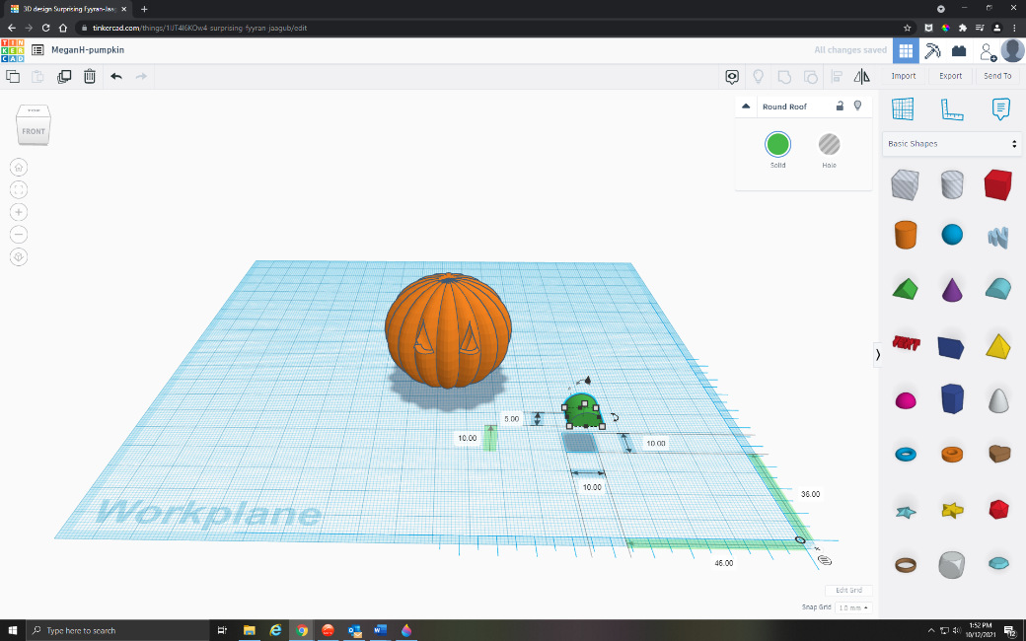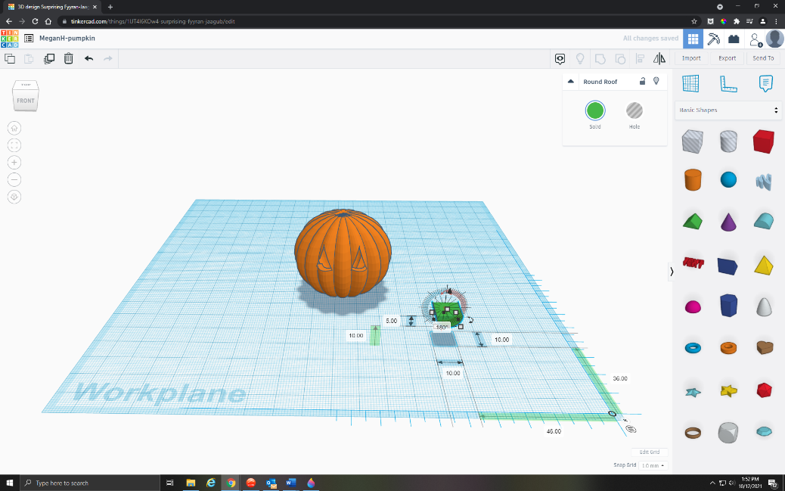

On the right side of the screen, click on the shape that says Round Roof.

Drag the shape onto the Workplane, and change the dimensions to your liking. (I chose 5 height, 10 width, and 10 length.)

On the Z Axis, you should see a dimension for height above the Workplane—right now, this is 0.00, and it’s indicated by an upward pointing arrow.

Adjust that dimension to the height you like—I chose 10.

Clicking on the rotate icon on your shape, rotate mouth 180 degrees to form a smile.
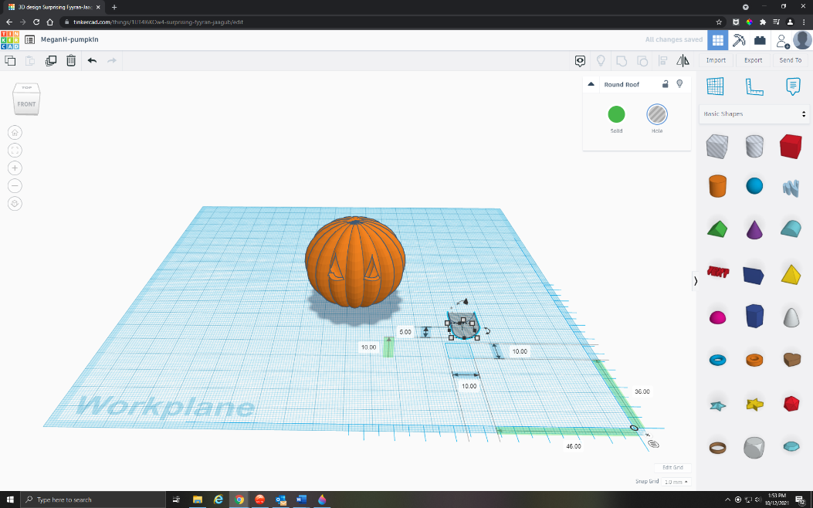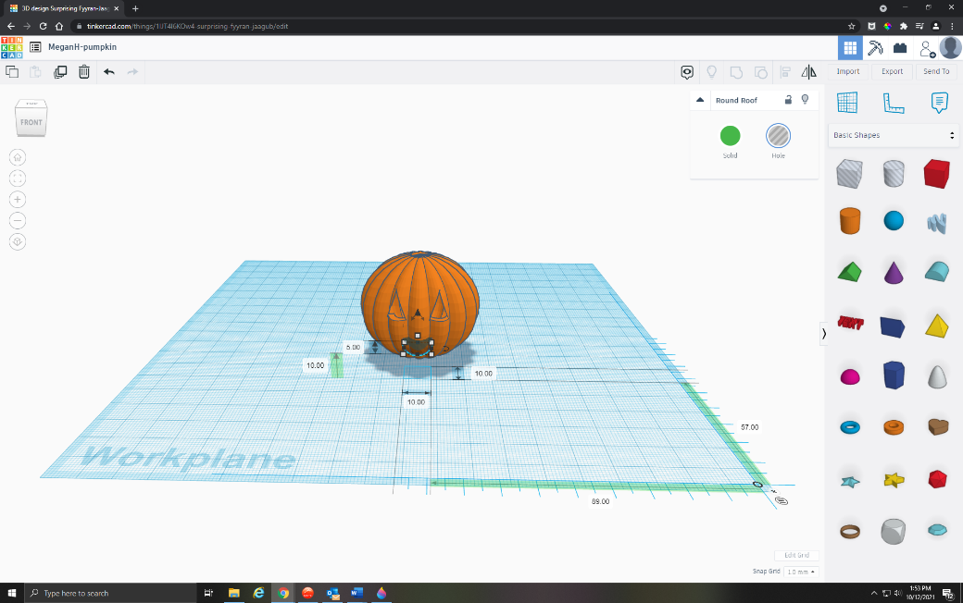

Change your mouth from Solid to a Hole.

Using the Arrow Keys, move the mouth slowly into your pumpkin. Don’t push it entirely inside, because we want to leave some sticking out so that it completely forms the mouth hole.

Select your entire pumpkin, then click CTRL + G to group everything together again.

You should now have a pumpkin with two eye holes and a grin.

OR Step 6: Give Your Pumpkin a Mouth – Spooky Scribble Version.

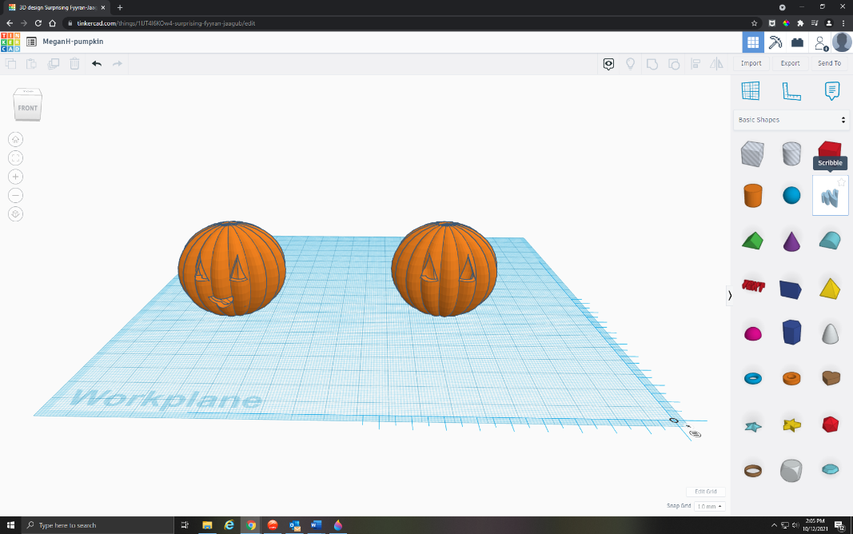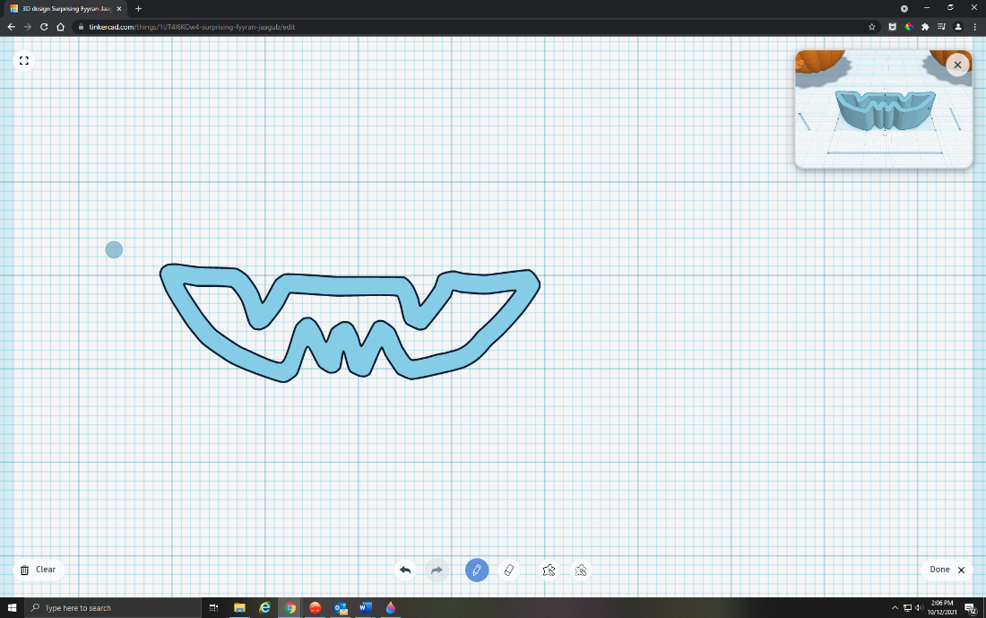
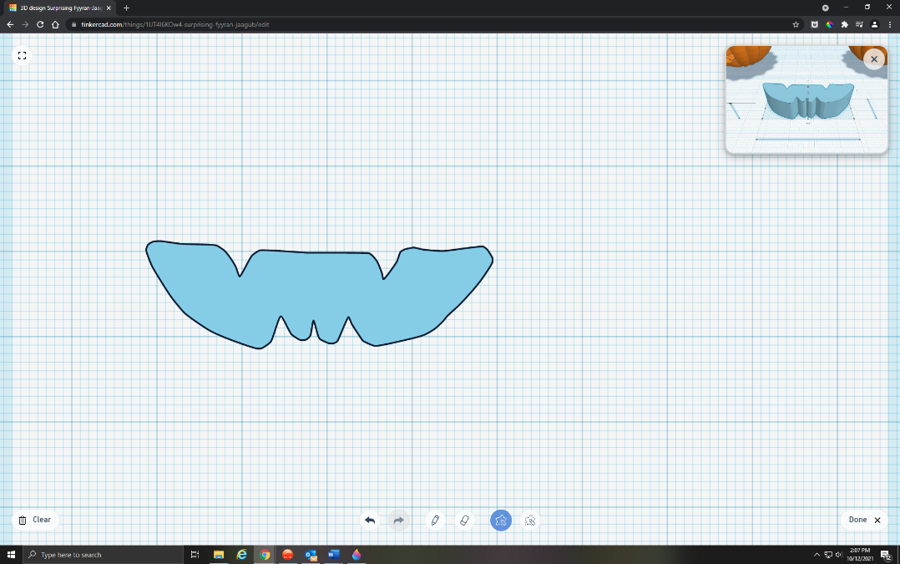

On the right side of the screen, click on the shape called Scribble.

Drag the shape onto the Workplane.

You can now draw your own scribble! Using the mouse, I carefully drew a toothy jack-o’-lantern grin in one continuous motion—once you end back where you began, you can stop holding down the left mouse button and see what you’ve created. (If you don’t like it, you can always erase it with the Erase button, switch back to the Draw button, and try again.)

Switching to the Draw Shapes button, I filled in the empty space of my toothy grin so that it was one full shape rather than an outline. Once you have the mouth to your liking, click Done in the bottom right corner

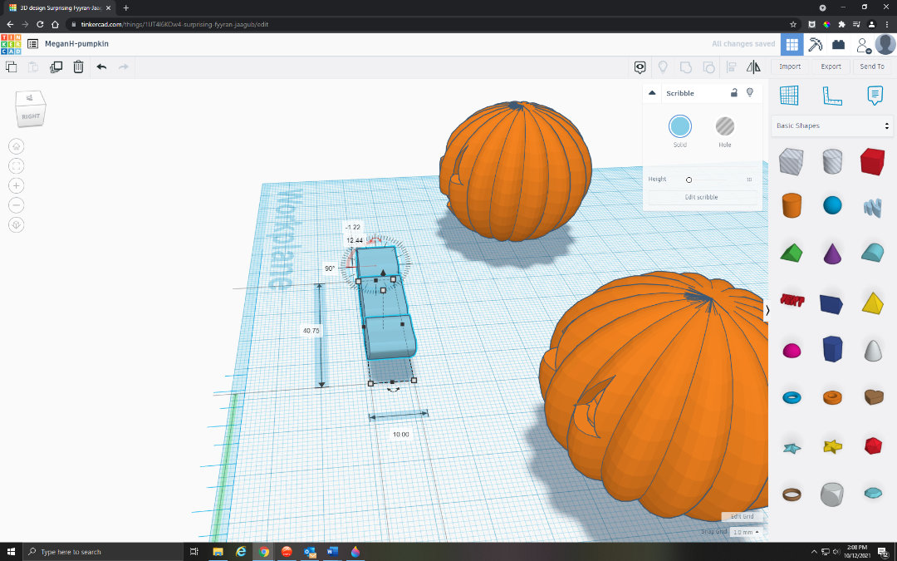

Back on the Workplane, you’ll notice that your mouth is face down—clicking on the Z Axis rotate button, you’re going to rotate your mouth around 90 degrees.
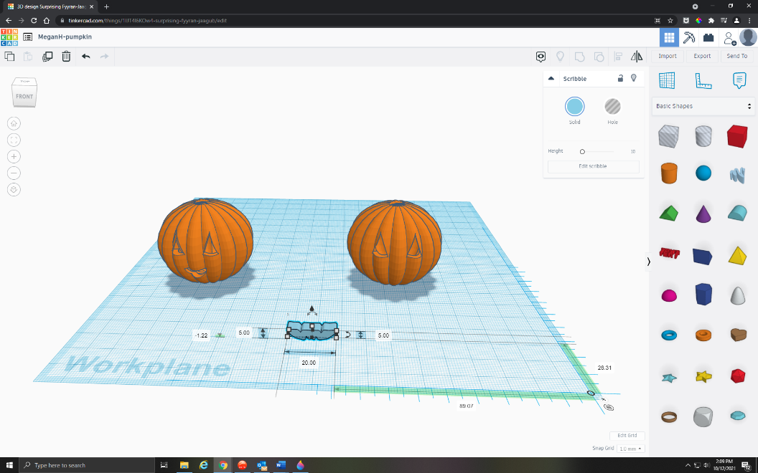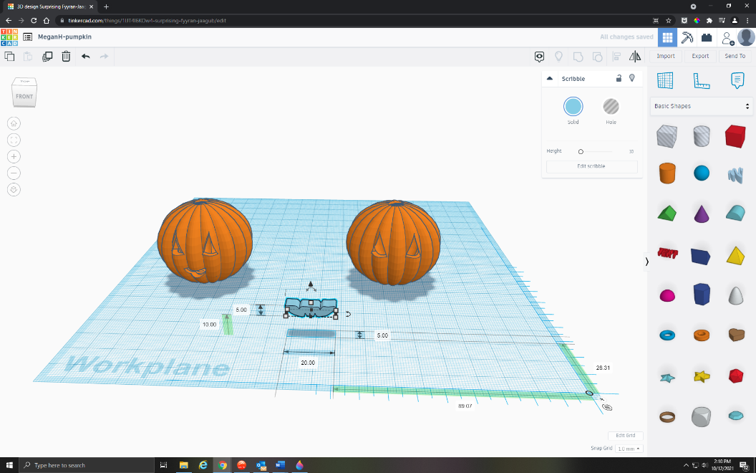

Change the dimensions to your liking. (I chose 5 height, 20 length, and 10 width.)

On the Z Axis, you should see a dimension for height above the Workplane—right now, this is 0.00, and it’s indicated by an upward pointing arrow.

Adjust that dimension to the height you like—I chose 10.
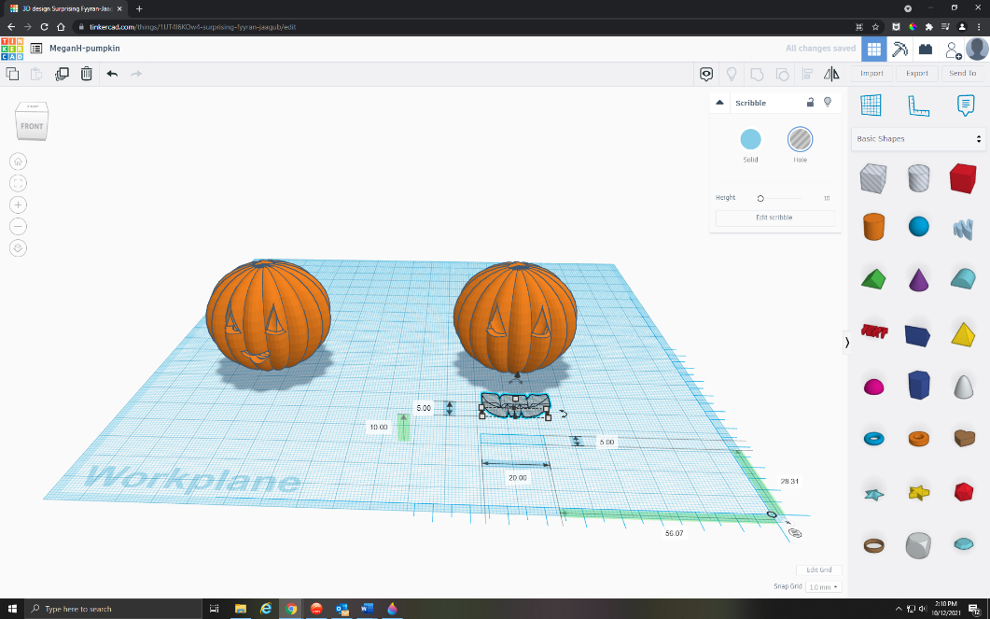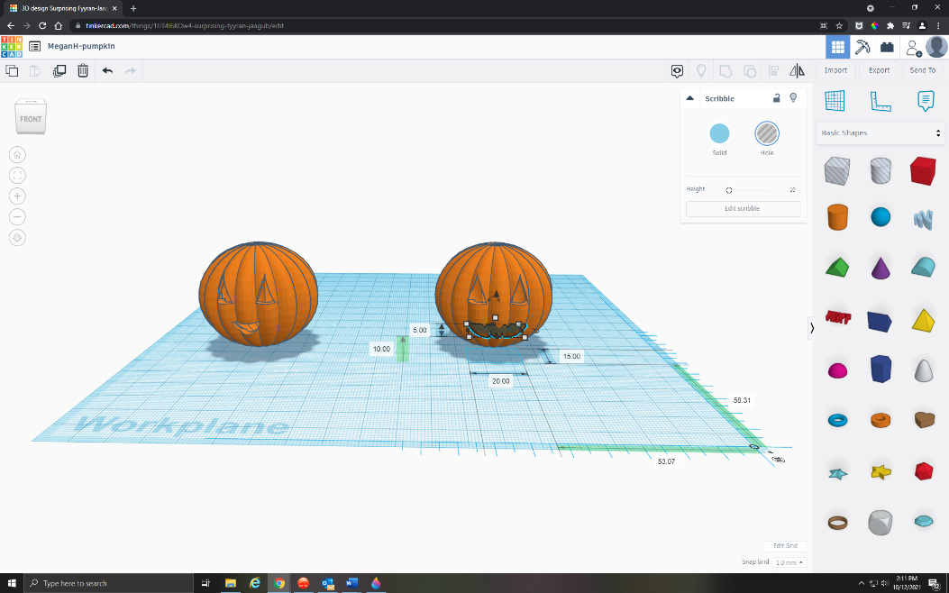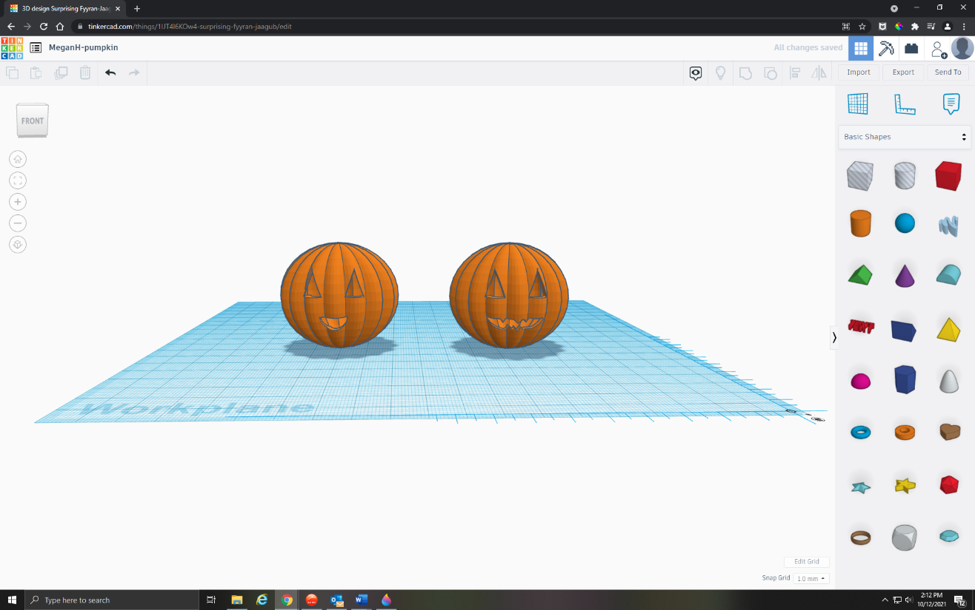

Change your mouth from Solid to a Hole.

Using the Arrow Keys, move the mouth slowly into your pumpkin. Don’t push it entirely inside, because we want to leave some sticking out so that it completely forms the mouth hole.

Select your entire pumpkin, then click CTRL + G to group everything together again.

You should now have a pumpkin with two eye holes and a toothy grin.

Step 7: Add a Stem to Your Pumpkin

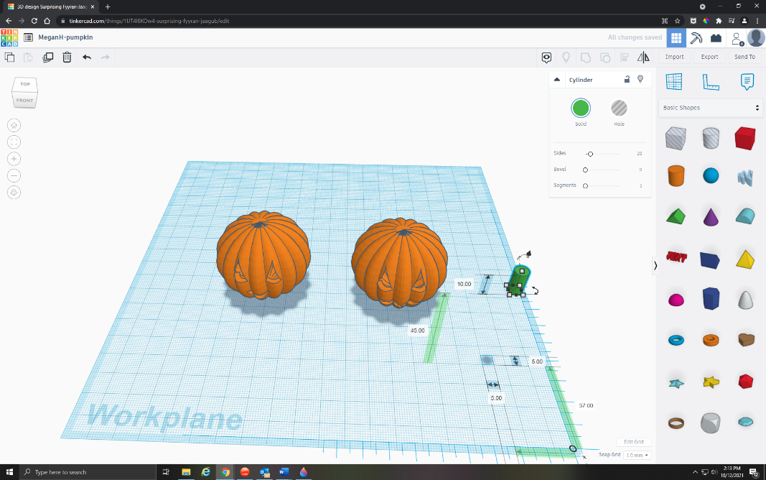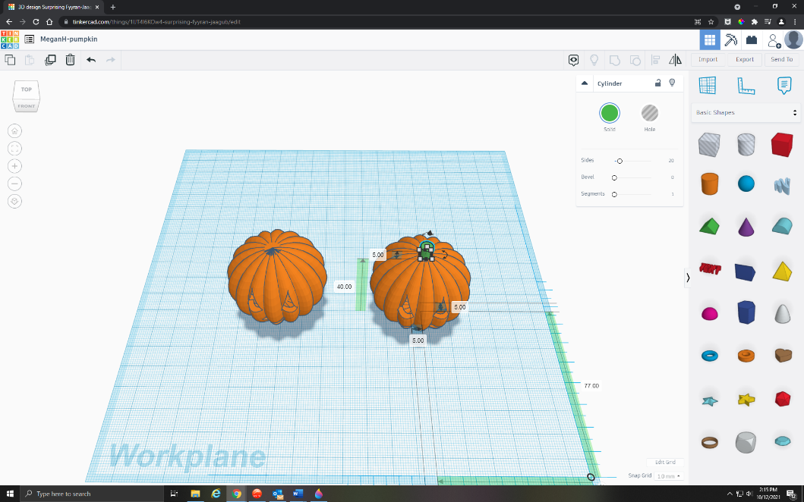

On the right side of the screen, click the shape called Cylinder or Polygon. (Your choice!)

Drag the shape onto the Workplane, and change the dimensions to your liking. (I chose 5 height, 5 width, and 5 length.)

On the Z Axis, you should see a dimension for height above the Workplane—right now, this is 0.00, and it’s indicated by an upward pointing arrow.

Adjust that dimension to the height you like—I chose 40, so that it sits right on top of my pumpkin.

Using the Arrow Keys, move the stem slowly on top of your pumpkin. Using the top view, check to make sure that it’s nicely centered on top.

Select your entire pumpkin, then click CTRL + G to group everything together again. You’ll notice that your pumpkin is now all the same color.

You should now have a pumpkin with two eye holes, a toothy grin, and a little stem on top!

Step 8: Export Your Pumpkin for Printing

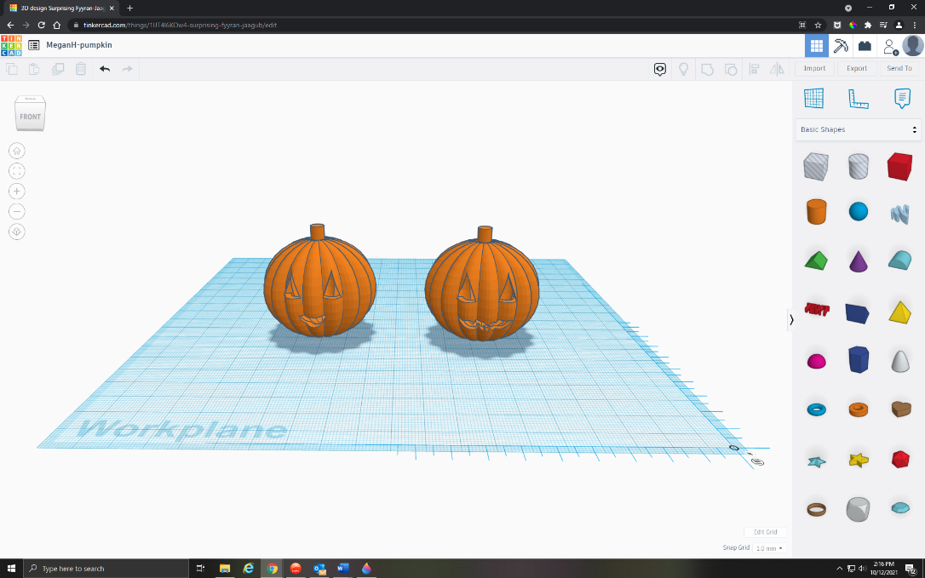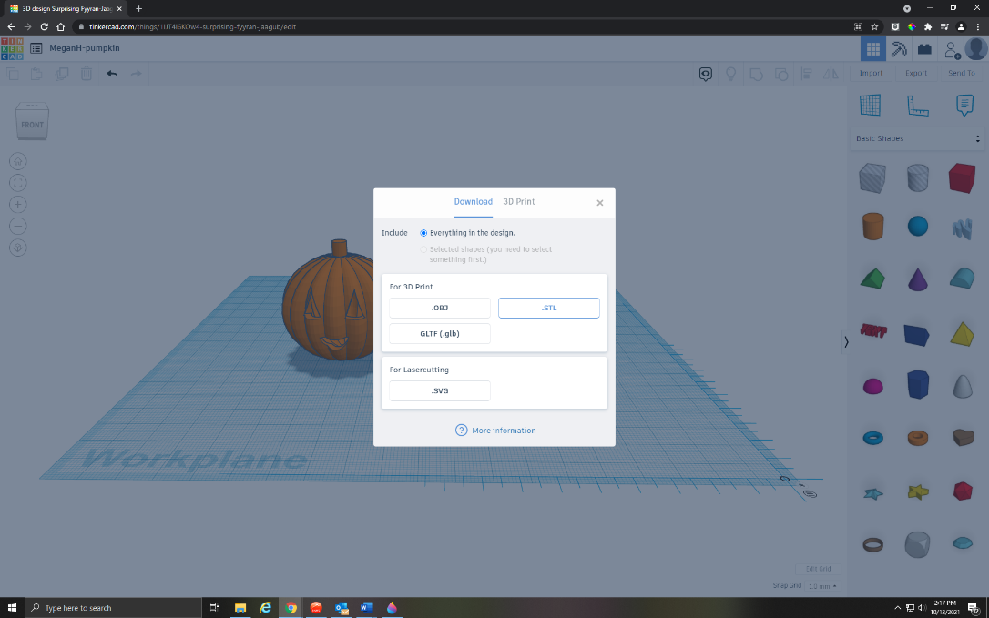

You will need to go to the right side of your screen and click the Export button.

A menu should appear and you will simply click the .STL button.

This creates a file that can be 3D printed, and if you open the file you will see your completed object.

And there you have it!

