Sources for Florida Water Advocates
Allan, Tony, Virtual Water. London, L.B. Tauris & Co. Ltd., 2011.
Barlow Maude, Blue Covenant: the global water crisis and the coming battle for the right to water. New York, London: The New Press, 2008.
Barnett, Cynthia, Mirage, Florida and the Vanishing Water of the Eastern U.S. Ann Arbor, the University of Michigan Press, 2007.
Blain, L. M., “Florida’s Water: Who Owns It and By Whose Authority.” Water, Florida Law, University of Florida Digital Collection. http://ufdc.ufl.edu/WL00000151/00001?search=owns+=water
“Climate Change in South Florida.” Florida Center for Environmental Studies. http://www.ces.fau.edu/climate_change/
“Florida’s Drinking Problem-Unsafe Water, Widespread Potable Water Violations but Virtually Nonexistent Enforcement.” August 11, 2016, http://www.peer.org/news/news-releases/florida%E2%80%99s-drinking-problem-%E2%80%93-unsafe-water.html
Knight, Robert L. Silenced Springs, Moving from Tragedy to Hope. Gainesville, Florida: Howard T. Odum Florida Springs Institute, 2015.
Leahy, Stephen, Your Water Footprint: The Shocking Facts About How Much Water We Use to Make Everyday Products. Buffalo, New York: Firefly Books, 2014.
Pittman, Craig and Matthew Waite. Paving Paradise: Florida’s Vanishing Wetlands and the Failure of No Net Loss. Gainesville: University of Florida, 2009
Staletovich, Jenny, “Florida Drinking Water Ranks Among Nation’s Worst, Study Finds.” Miami Herald, May 02, 2017. http://www.miamiherald.com/news/local/environment/article148112799.html#storylink=cpy

Stanton, Elizabeth A., and Matthew Taylor, “Valuing Florida’s Clean Waters.” Stockholm Environment Institute – U.S. Center. November 13, 2012. http://earthjustice.org/sites/default/files/ValuingFloridasCleanWaters.pdf
Swihart, Tom, Florida’s Water, A Fragile Resource in a Vulnerable State. New York: RFF Press, 2011.
The Howard T. Odum Florida Springs Institute https://floridaspringsinstitute.org/
The Water Footprint Network: https://waterfootprint.org/en/
“2016 Florida Infrastructure Report Card.” American Society of Civil Engineers. http://www.infrastructurereportcard.org/florida/florida-infrastructure
WEBinar.1000 Friends 2070 Water Report. February 15, 2016, https://handouts-live.s3.amazonaws.com/fdf2acce9c984c5fafa6e730e8e64f8d?sessionId=8563181653799509001&participantId=1000066

JOHN M. DUNN johnmdunnfreelancewriter.com
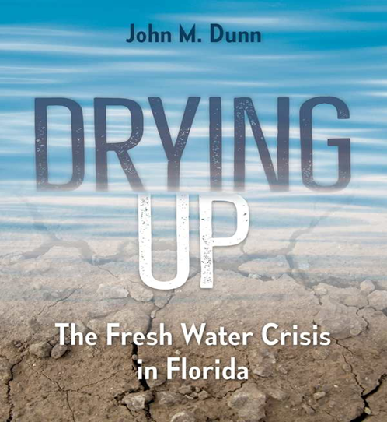
https://upf.com/book.asp?id=9780813056203
Use the code: WATER for free shipping and discounted price
Goals for a Florida Water Advocates
- Persuade the state legislature and local governments, water management districts, utilities, and water policy makers to:
- adopt Soft Path water policies;
- mandate septic tank inspections statewide, hold polluters responsible
- restore springs, rivers, and hydrologic systems,
- restrict new water permits, meter all existing wells
- adopt meaningful nutrient reduction program,
- stop using public funds to entice more residents and tourists to Florida,
- bring back state-supervised Growth Management,
- honor and implement The Water and Land Conservation Amendment,
- require all waste water to be treated at Advanced Water Treatment Facilities,
- get real about climate change

- Lead by example: 1. curb outdoor use of fresh water on lawns and landscape 2. follow the examples of the determined activists of the 1970’s who showed us what citizens can do to protect natural resources 3. expect to pay more for water and meter private wells (pay for the actual value of the resource) 4. get involved and support local and state water advocacy groups 5. Choose politicians who understand water issues
Organizations
Sierra Club, Audubon, Florida Defenders of the Environment, Florida Wildlife Federation, Everglades Foundation, Conservation Trust for Florida, Earthjustice, 1000 Friends of Florida, the Florida Conservation Coalition, the various Riverkeepers such as the St. Johns Riverkeeper, Rainbow River Conservation, the Miami River Commission, the Indian River Land Trust, and Northwest Florida Environmental Conservancy, the Howard T. Odom Florida Springs Institute.

