Supply Listing: Nature-Inspired or Flower Mandalas
Instructor Ellen Goldberg
Clear Contact Paper (around two feet or more).
Square piece of white paper 12” or 14” square.
Assortment of flower parts (From your garden or a walk or a day’s sweepings from a floral shop which they will give to you upon pre-arrangement)
Scissors
Compass
Pencil
Ruler

©2020 Ellen Goldberg

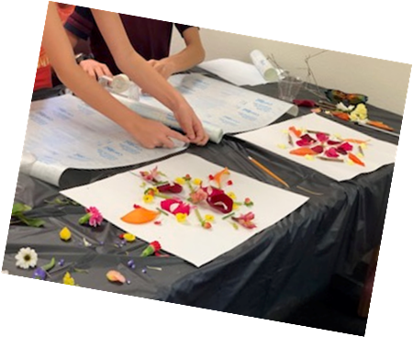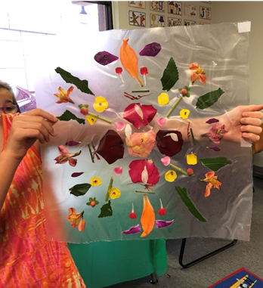

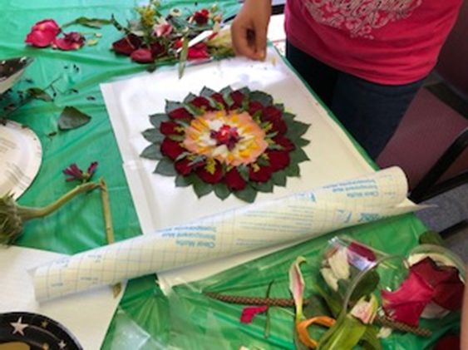

©2019 Ellen Goldberg

Instructions: Flower Mandalas with Ellen Goldberg

- Cut 2 square pieces of clear Contact paper (roughly 12” or 14” square)
- Assemble floral parts, cutting as needed (use flat pieces) onto white square piece of paper playing with a variety of designs until you find one you like.
- Your design will be circular in shape and though it may not be necessary you may draw or trace a circle onto the white piece of paper before placing your flower components onto it. Leave 1” -3” inches on each side.
- Part of the practice of making mandalas is to experience mindfulness. If you are gathering materials outdoors enjoy a walk in nature and relax your mind. When you begin to put your materials together focus on pleasant thoughts and then on your design.
- Begin at the center of the circle and create symmetry (balance) outward.
- When you are satisfied with your design you may transfer your floral components to a piece of contact paper from which you have removed the white or clear paper from the sticky side. Place the sticky side up and place your parts onto the sticky side.
- Take another pre-cut piece of clear contact paper and remove the white or clear sheet from the sticky side. Place the sticky side on top of the sheet onto which you have placed the flowers. You may need another person to help you in-order to prevent bubbles and folds in the contact paper.
- Now press both sides together to seal. Hold up to the light and you have a beautiful mandala where the light may come through if you left areas open.
- For ideas and inspiration please go to my Pinterest board https://www.pinterest.com/ellensgoldberg/mandalas/

©2020 Ellen Goldberg

