Supply Listing: Fabric Bowls
Instructor Ellen Goldberg
Bowl (smooth inside and out with sides 2” or higher) Size of cereal or soup bowl
Assortment of cotton fabric cut into 1” -2”” wide strips in 6”-9” lengths.
Mod Podge or a mixture of white glue with water, container
Plastic wrap
Foam brush
Water container
Fabric or regular scissors

©2020 Ellen Goldberg
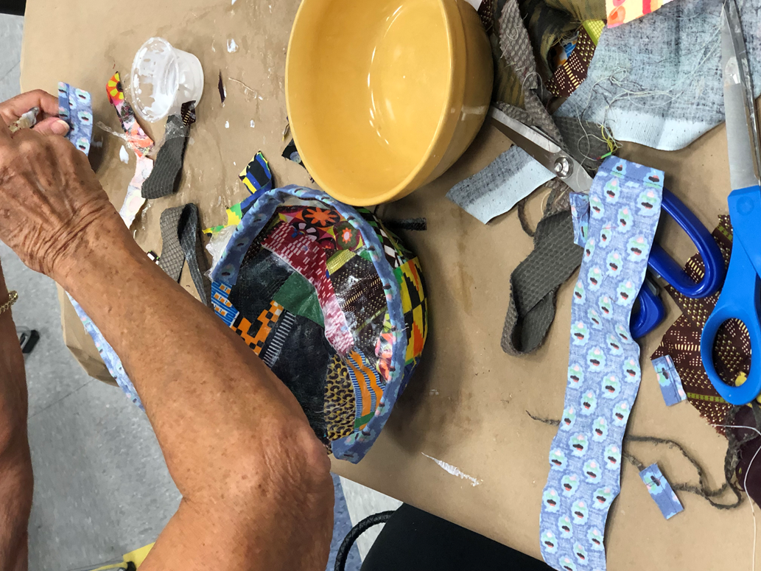

©2019 Ellen Goldberg

Instructions: Fabric Bowls with Ellen Goldberg

- Select bowl
- Cut fabric strips
- Cover bowl with plastic wrap on the inside and outside.
- Pour Mod Podge into container and slightly thin with water.
- Flip the bowl upside down and brush a strip of Mod Podge onto the plastic covering of the bowl.
- Lay a strip of fabric, print side down onto the bowl. Continue this process until the bowl is covered.
- Apply more sections of Mod Podge and another layer of fabric right side up to the bowl entirely covering the first layer.
- Allow bowl to dry.
- When the bowl is dry remove the formed fabric in one piece from the original bowl peeling plastic wrap away.
Trim edge excess in any way you want. You may choose to glue a piece of bias tape around the edge or another fabric piece at this point or to add beads or other interesting trims and components like feathers, etc.

©2020 Ellen Goldberg

